**RESEARCH AND COMMUNITY SERVICE GUIDELINES EDITION XIII REVISION OF 2021**

By: **Chalid Luneto**. December 16, 2021. 15:24:41

RESEARCH AND COMMUNITY SERVICE GUIDELINES EDITION XIII REVISION OF 2021

The Ministry of Education, Culture, Research, and Technology

December 16, 2021

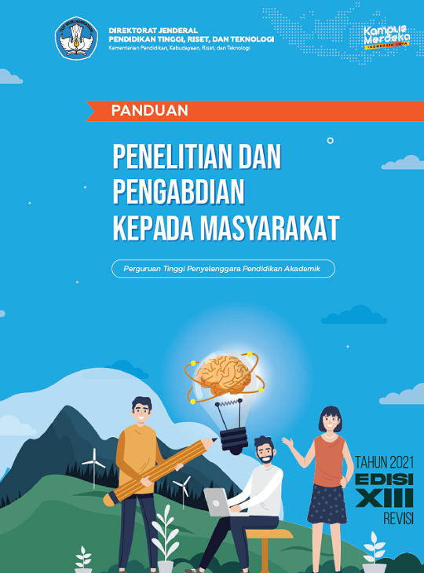

Directorate General of Higher Education, Research and Technology

Ministry of Education, Culture, Research and Technology

Independent Campus

Guideline

Research and Community Service

College Provider of Academic Education

The year of 2021

Edition XIII

Revision